**Inferences from visualisations in Tableau (scroll down for PowerBi)**

Manimanya Reddy JV

1. Crime by hour –

With respect to crime by the time of the day, Vehicles being stolen or simple assaults and vandalism was typically observed at 44.44% in the early morning to late night timings while Mornings are the next expected time having 27.05%

1. Crime by location – The 77th street is a criminal hostpot with an approximate 3% victims for every 1000 people. Followed by Southwest and pacific regions.

1. Types of crime- From the bubble chart its deduced that the most often mode of Assaults are via Physical assaults of hands, fist, feet and bodily force followed by verbal threats and handgun in some cases

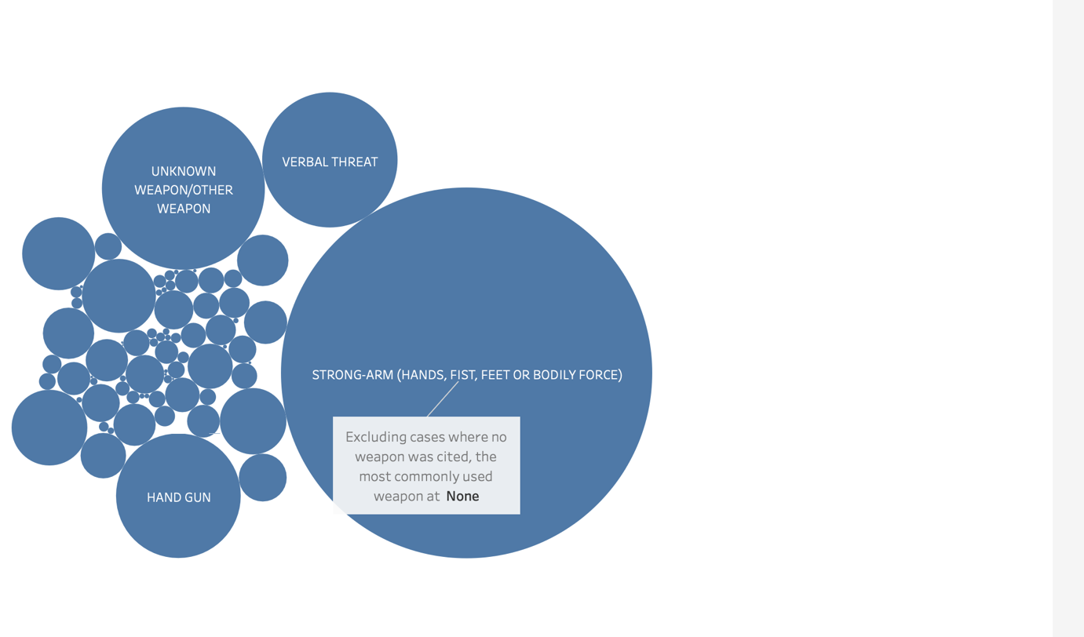

1. Victims age by gender- It’s a disappointing fact of LA on the crime rate being dominant on both female and male with 51.36% for males and 47.61% for females in the year 2020

1. Total arrests – Invest counts and adult arrests are predominantly observed while juvenile arrests are rarely encountered

1. Crime rate over time – Subsequently we can observe a dop in the graph as 2021 proceeded by initially stating off with a 1.8% in 2020  
  
  
  
  
  
  
  
  
  
  
  
  
  
  
  
  
  
  
  
  
  
Inferences from PowerBi

1. Crime rate over time – It is observed that January is the peak of Crimes taken place in year 2020 and 2021 with approximately 20k in each year of victims with Highest on Fridays as per day time factors chart

1. Day time week factors – Dominantly observed on Fridays and Saturdays, The crime rate in the nights are seen to take a peek.

1. Crime by location – As per the visualised map the count of crime rates are highest in regions of 77th street and central, pacific regions

1. Type of crime- Majorly a victim of bodily forces like physical assaults via hands, feet and fist. Its observed the usage of weapons to be the next immediate mode of crime.

1. Arrests ratio – Majorly seen for Invest cont and adult arrests in the 408k crime details

1. Demographic analysis – The victims age varied majorly from 30 years to 25 years old to encounter to a crime.

